Dr. Doriana Medić’s Visit
April 20–29, 2024
May 8, 2024

Our Guest
Dr. Doriana Medić is a Computer Science Assistant Professor (RTDA) at the University of Turin, Italy. She obtained her Ph.D. degree in Computer Science and Systems Engineering at IMT School for Advanced Studies Lucca, Italy, with a thesis on the expressiveness of calculi for reversible concurrency, after her Master’s degree in Mathematics in Engineering at the Faculty of Technical Sciences, Serbia, and her Bachelor’s degree in Applied Mathematics at the Faculty of Science in Novi Sad, Serbia.
Her research focuses on the interplay between formal methods, concurrent, distributed and reversible computing. More recently, her interests are in federated learning and workflow modeling.
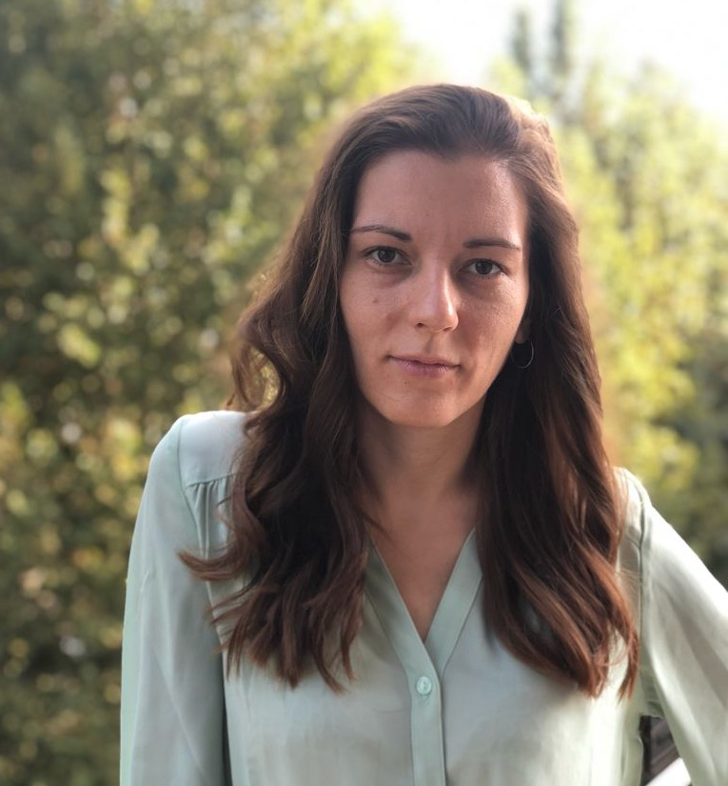
Photo courtesy of Dr. Medić.

Itinerary
Day | Hour | Event | Place
Sat. 4/20 | 4:15PM | Arrival at the Atlanta Airport (DL0175) | -
Sun. 4/21 | - | - | -
Mon. 4/22 | - | - | -
Tue. 4/23 | 1:00PM – 2:00PM | Crossing Cultures, Building Bridges: A Woman’s Journey in Computer Science | Summerville Campus - UH 348
–〃– | 5:30PM – 7:00PM | Three minutes thesis | Health Sciences Campus - GB 1110
Wed. 4/24 | 11:00AM - 12:00PM | Reversible $λ$-calculus w/ Logan Beatty | Summerville Campus - UH 122
–〃– | 3:45PM - 5:30PM | WiCyS meeting | GCC - Shaffer MacCartney Lobby
Thu. 4/25 | 5:30PM – 6:45PM | Intervention in CSCI 1301 | Summerville Campus - UH 170
Fri. 4/26 | 12:00PM - 2:00PM | PL reading group’s Spring 2024 Awards Gala | Hildebrandt’s
–〃– | 3:00PM - 4:00PM | SCCS Research Colloquium | GCC (RV 2809) and remotely
Sat. 4/27 | - | - | -
Sun. 4/28 | - | - | -
Mon. 4/29 | 6:50PM | Departure from the Atlanta Airport (DL0174) | -

Crossing Cultures, Building Bridges: A Woman’s Journey in Computer Science
This talk captures the experiences of a woman in the Computer Science field, whose academic journey spans geographical and cultural boundaries. Starting from her roots in mathematics in Serbia to her pursuits in Computer Science in Italy and France, she has encountered diverse countries, cultures, and professional environments. Throughout her journey, she has faced both professional and personal challenges while navigating the male-dominated field of STEM and adapting to various working and living environments.
Slides by Dr. Medić
Joint meeting with Girls who code, ACM, WiCyS.
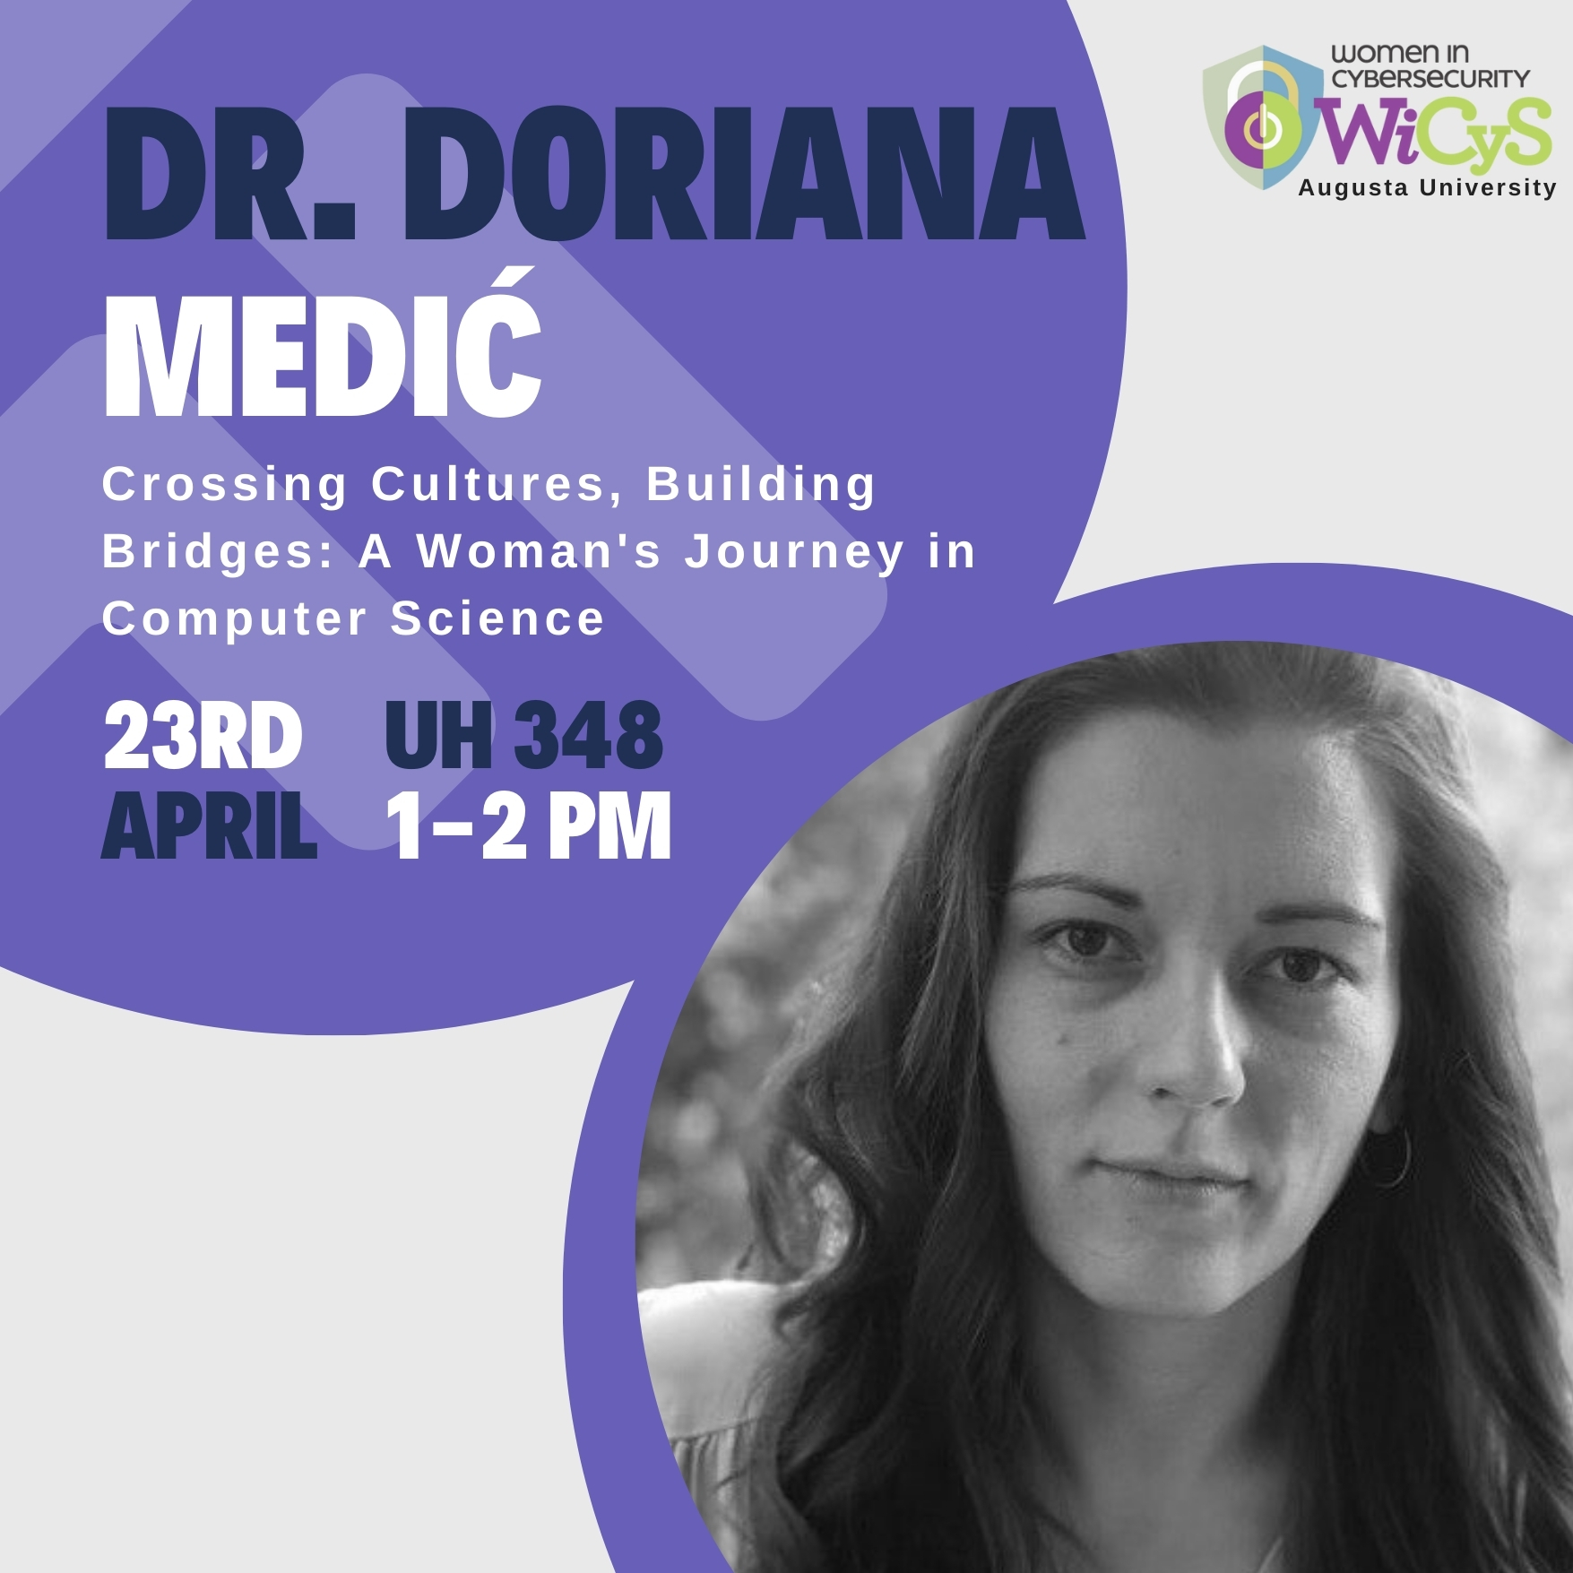
Flyer by Deniz.

Reversible $λ$-calculus
Logan Beatty presented the results of the investigations led during Spring 2024’s CSCI 4990 - Undergraduate Research.
Slides by Logan Beatty

SCCS Research Colloquium
Title:
Formal Methods in Action: Enhancing Workflow Formalization
Abstract:
Designing complex applications and executing them on large-scale topologies of heterogeneous architectures is becoming increasingly crucial in many scientific domains. Consequently, properly supporting the modularity and complexity of modern scientific applications requires new approaches to workflow execution, like seamless interoperability between different workflow systems, distributed-by-design workflow models, and automatic optimisation of data movements. However, the existence of diverse workflow modeling paradigms, many lacking formalization, makes comparison and switching between systems challenging. To address this, we are working on leveraging formal methods to create an intermediate representation language for scientific workflows. This language should focus on serving as a low-level compilation target rather than being designed for human interaction. Key features include semantics based on low-level primitives and a formal framework to ensure consistency and accuracy in translating workflow models into the proposed language. Additionally, it should offer the rewriting rules designed to optimize execution traces, accompanied by corresponding equivalence.
Joint work with Iacopo Colonnelli, Alberto Mulone, Marco Aldinucci, Viviana Bono and Luca Padovani.
Slides by Dr. Medić

Basic Facts
Visiting Faculty Information:
Name (Last, First): Medić, Doriana
Department: Dipartimento di Informatica, University of Turin
Email address: doriana.medic@unito.it
Website: https://alpha.di.unito.it/doriana-medic/
CV: Doriana_Medic_cv.pdf
Sponsoring Faculty Information:
Name (Last, First): Aubert, Clément
Department: School of Computer and Cyber Sciences
Phone: (+1)706-737-1566
Email address: caubert@augusta.edu
Contact information and office hours: https://spots.augusta.edu/caubert/#contact
Sponsoring Department Manager Information:
Name (Last, First): White, Regina
Department: School of Computer and Cyber Sciences
Phone: (+1)706-721-0664
Email address: rhull@augusta.edu
Sponsors:
Dr. Medić’s visit was made possible thanks to the generous sponsor of Offices of Diversity and Inclusion’s Faculty Inclusive Excellence Initiative and the logistic support of the School of Computer and Cyber Sciences and the International and Postdoctoral Services Office. The Girls who code, ACM, WiCyS and ΔΛΔ student organization were also a big help.
Alternative formats:
This document is available as a webpage, and as pdf and docx documents.

